The notation ‘DP’ in a rule of the sailing instructions (SIs) means that a boat may be protested and subject to a discretionary penalty.

- RULES
  - The racing series will be governed by the rules as defined in The Racing Rules of Sailing (“RRS”), and the spirit of the class rules for the Melges 24 and J/80.
  - The following RRS are changed:
    - RRS 40.1 shall apply at all times on the water. In addition, the end of the first sentence of RRS 40.1 is changed to read “except while actively adding or removing clothing.” Competitors must may supply their own USCG-approved PFDs. PFDs shall be worn outside of all clothing.
    - Rule 60.4(a)(2) is changed as follows: (2) if it alleges a breach of a rule of Part 2 or rule 31 and is from a boat that was not involved in, and did not see, the incident, or.
  - RRS 60.4(a)(2) is deleted.
  - Any boat making contact with any non-inflatable mark (e.g. government mark), race committee boat, other non-racing vessels, or anchor lines shall immediately contact the RC, retire for the evening, and return to the dock. An incident report must be filed. A Request for Hearing for Redress may be submitted.
  - RRS 61.4(b) is amended to add: (6) a collision where no injury or physical damage was incurred and the boat seeking redress wasn't disqualified by a committee decision.

- CHANGES TO SAILING INSTRUCTIONS
  - Any change to the Sailing Instructions will be posted on the Club website or next to the Club Float Plan Sign-In Binder located at Brooklyn Bridge Sail Club. office before 1730 on the day it will take effect.
  - Changes to a sailing instruction may be made on the water by the Race Committee hailing all boats on VHF Ch 71 (‘VHF Race Channel’).

- COMMUNICATIONS WITH COMPETITORS
  - Notices, including amendments to the Notice of Race or the Sailing Instructions will be posted on the Club website (https://brooklynsailclub.com/racing/) or near the Sail Club Float Plan sign-in binder located at the Brooklyn Bridge Sail Club office or docks.
  - (DP) Except in an emergency or to report a protest or withdrawal, or as otherwise provided herein, a boat shall neither make radio transmissions while racing nor receive radio communications not available to all boats.
  - The Race Committee may announce changes to the starting line, finish line or the course on the VHF Race Channel. Failure to hear such broadcasts shall not be grounds for redress.

- SIGNALS MADE ASHORE
  - Signals made ashore will be displayed at Brooklyn Bridge Sail Club. docks and announced on VHF Race Channel.
  - When pennant “AP” is displayed ashore, “one minute” is replaced with “not less than 30 minutes” in Race Signal “AP”.

- SCHEDULE OF RACES
  - Practice Race days are scheduled for April 29 and 30
  - Races are scheduled for the following days in 2026
Spring Series (7 evenings)
Wednesday evening: May 7, 14, 21, 28 and June 4, 11, 18
Thursday evening: May 8, 15, 22, 29 and June 5, 12, 19
Summer Spring Series (6 evenings)
Wednesday evening: May 6, 13, 20, 27 and June 3, 10
Thursday evening: May 7, 14, 21, 28 and June 4, 11
Summer Series (7 evenings)
Wednesday evening: June 17, 24, July 1, 8, 15, 22, 29
Thursday evening: June 18, 25, July 2, 9, 16, 23, 30
Fall Series (7 evenings)
Wednesday evening: August 2, 12, 19, 26 and September 2, 9, 16
Thursday evening: August 3, 13, 20, 27 and September 3, 10, 17

  - The scheduled time of the warning signal for the first race is 1825.
  - To alert boats that a race or sequence of races will begin soon, sound signals at least one minute before a warning signal may be made.
  - It is the intention of Race Committee to hold more than one race on any evening for the Melges 24 and J/80 Fleet consistent with available daylight.
  - If the Race Committee intends to start another race on the same day, it will display an orange flag (with no sound) while boats are finishing or make an announcement over the VHF Race Channel. Boats awaiting the start of an additional race should assemble in the vicinity of the downwind end of the course and stay clear of boats that are still racing.
  - The next race will begin as soon as practicable after the previous race.

CLASS FLAGS
  - The class flag for the combined Melges 24 & J/80 fleet is the Numeral Pennant 1. If the two fleets are started separately, the Numeral Pennant 1 will be used for the Melges 24 and the Numeral Pennate 2 for the J/80.

RACING AREA
  - The races are located in the vicinity of the Gowanus Flats near Red Hook Channel. Communication for racing will be conducted on the VHF Race Channel

THE COURSES
  - The course for each race will be Windward-Leeward using drop marks or government marks (WL) or courses around government marks, as provided in Sailing Instruction 10.1.
  - The windward marks are to be rounded to port. Two windward marks may be laid or designated where are multiple fleets
  - For WL courses, the Race Committee signal boat will announce or display the number of legs. Courses will be announced as “Course # and color/name of mark”, e.g. W2 Yellow windward, orange leeward.
  - For races WL course around government marks, marks will be announced or displayed on a course board or a white board. The information will be announced on the VHF Race Channel.

Single or Multiple Fleet using drop or government marks:

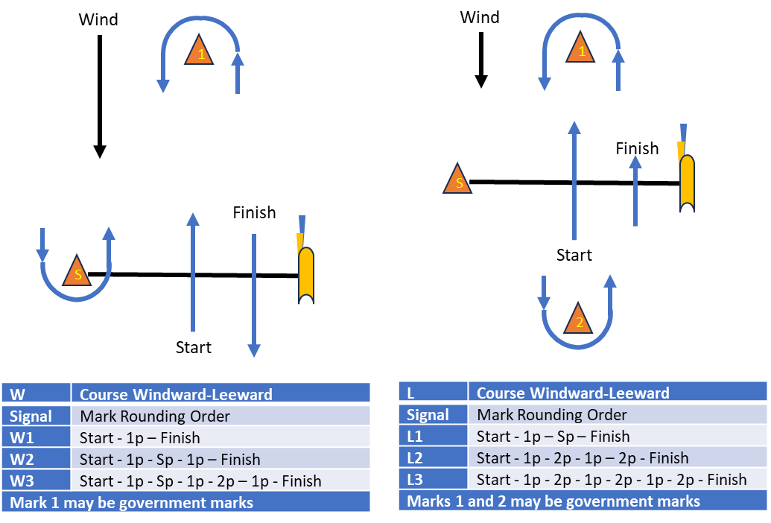

  - At the discretion of the Race Committee, one or more races in the series may be sailed around government marks from the start, around specified government marks and then to the finish.
  - If government marks are to be used, the Race Committee will signal the course by letters according to Sailing Instructions. Marks shall be rounded in the order signaled and left on the hand so that the rhumb line to the next mark will not cross the rhumb line from the previous mark. If the next mark is reciprocal, the mark shall be left to port when rounding.

MARKS FOR WINDWARD-LEEWARD COURSES
  - Marks for the W-L course will be a tetrahedron, a cylinder, special marks, or government buoys.
  - A new mark replacing an original mark will be a tetrahedron with a different color that the original mark.
  - The Race Committee, at its discretion, may set an offset mark, (a yellow cylinder). Windward offset marks will be to port of the windward mark(s).

MARKS FOR RACING AROUND GOVERNMENT MARKS
  - Marks for courses using government marks are shown in Appendix A
  - Mark X, if signaled, will be a special mark used anywhere in the course.

CHECKIN
  - (DP) Before the first warning signal of each day, all boats shall sail past the stern of the signal boat and check in by hailing their bow number. They shall continue to do so until their bow or sail number is verbally acknowledged by the Race Committee.

THE START
  - The starting line will be between a staff displaying an orange flag and the course side of the port-end small orange tetrahedron starting mark.
  - The Melges 24 and J/80 fleets may be combined into a single fleet for the start.
  - Boats whose warning signal has not been made shall keep clear of the starting area.
  - Use of an engine is permitted until one minute before the start signal as per RRS 42.3(i).
  - A boat that starts later than 10 minutes after her starting signal will be scored DNS without a hearing. This changes RRS A5.1 and A5.2.

CHANGE OF THE NEXT LEG OF THE COURSE
To change the next leg of the course, the Race Committee will move the original mark or set a change mark to a new position. There will be no offset mark for the changed windward mark.

CHANGE OF COURSE BETWEEN STARTS
  - If the Race Committee changes the first mark following a postponement during a starting sequence, flag C will be displayed with short, repeated sounds prior to the warning signal and the windward mark for all classes not yet started will be a new mark announced by the RC.

RECALLS
  - If any part of a boat’s hull is on the course side of the starting line at her starting signal and she is identified, the Race Committee will attempt to hail her hull number on VHF Race Channel. Failure to hail her number, failure of her to hear such a hail, or the order in which boats are hailed will not be grounds for redress. This changes RRS 61.1.

THE FINISH
  - The finishing line for all courses will be between a staff displaying an orange flag on an official boat and the course side of the finish mark.
  - When the orange flag is replaced with the Brooklyn Bridge Sail Club. as the finish flag, it means there is no more racing for the evening.
If the Race Committee is absent when a boat finishes, she should report her finishing time, and her position in relation to nearby boats, to the Race Committee at the first reasonable opportunity.

PENALTY SYSTEM
  - At the first reasonable opportunity during, or immediately after the race, a boat that accepted a One-Turn or Two-Turns Penalty shall report that fact to the Race Committee on the VHF Race Channel and identify the other boat(s) involved in the incident. This changes RRS 44.2.

TIME LIMIT AND TARGET TIMES
  - If no boat has rounded the first mark within 20 minutes, the race will be abandoned.
  - The time limit for any race is 60 minutes or 20 minutes prior to sunset whichever is sooner. If no boat has finished within the time limit, the race will be abandoned.
  - Unless SI 18.4 applies, any boat failing to finish within 10 minutes after the first boat finishes will be scored Did Not Finish without a hearing. This changes RRS 35, A4 and A5.
  - When the Melges 24 and J/80 fleets have the same start and the first boat that sails the course and finishes is a Melges 24, then any J/80 boats failing to finish within 12 minutes after that boat finishes will be scored Did Not Finish without a hearing. This changes RRS 35 and A5.

HEARING REQUESTS
  - The protest time limit is 15 minutes after the last boat docks.
  - Hearing requests shall be filed on the current US Sailing Hearing Request form. Hearing request forms are available from the Sailing Center Associates, located at Brooklyn Bridge Sail Club. docks. Protests and requests for redress or reopening shall be delivered there within the appropriate time limit.
  - Notices will be posted no later than 10 minutes after the protest time limit to inform competitors of hearings in which they are parties or named as witnesses.
  - RRS 60.2(a)(1) modified to add “A boat intending to protest another shall hail “protest” via VHF Race Channel stating the protesting boat number and the protestee boat number.”
  - A boat intending to protest shall comply with RRS 60.2 and additionally report to the Race Committee (signal boat or finish boat) as soon as possible after finishing, giving the Race Committee its bow number and the bow numbers of the protested boat(s). This changes RRS 60.2.
  - All incidents that involve contact are an automatic protest. Both boats must comply SI 19.1 and 19.2.
  - To educate Club Members in protest sessions and the racing rules, protest hearings will be held at the Brooklyn Bridge Marina docks in an open forum as soon as possible after the day of racing.

SCORING
  - The Melges 24 and J/80 fleets will be scored separately.
  - One race is required to be completed to constitute a series.
  - The scoring system will be the Low Point System of Appendix A of the RRS, as modified as follows:
- Rule A5.3 applies. DNS, RET or DSQ shall be scored points for the finishing place one more than the number of boats that came to the starting area for the first race. A boat that did not come to the starting area shall be scored points for the finishing place one more than the number of boats entered in the series.
- When fewer than 5 races have been completed, a boat’s series score shall be the total of her scores.
- When 5 or 6 races are completed in a series, the boat’s score shall be the total of her scores excluding her worst score.
- When 7 or 8 races are completed in a series, the boat’s score shall be the total of her scores excluding her two worst scores.
- When 9 to 12 races are completed in a series, the boat’s score shall be the total of her scores excluding her three worst scores.
- When 13 races or more races are completed in a series, the boat’s score shall be the total of her scores excluding her four worst scores.
  - If a Sail Club racing team’s assigned boat is not available for the racing due to a breakdown, a request for redress can be submitted.
  - Late entrants must participate in a minimum of four race days of the series to be eligible for any prize that might be awarded for that series.
  - A boat that is unable to race because its assigned boat is not available will be given average points for those races that it misses.
  - Scoring of boats involved in a RRS 14 protest will be:
- The boat found to have broken RRS 14 shall be disqualified for that race.
- The boat found to not have broken RRS 14 or any other rule for that race will be scored RDG with average points at the end of the series.
- The boat that broke RRS 14 shall be scored DNC for subsequent races for that evening.
- The boat that did not break RRS 14 shall be scored RDG with average points for the series

SAFETY REGULATIONS
  - A boat and its crew shall at all times keep clear of all commercial vessels and shall not maneuver in any manner which would cause a commercial vessel to be unable to sail its proper course or carry out its commercial functions in a normal manner.
  - A boat whose actions or maneuvers result in danger signal (5 or more blasts) from commercial vessels shall be protested by the Race Committee. The penalty for breaking this rule shall be disqualification from the race.
  - A boat that retires from a race shall notify the Race Committee as soon as possible.
  - All boats shall continuously monitor the VHF Race Channel throughout the race.
  - Any COB situation will result in the immediate abandonment of the race and all boats must standby to provide assistance as directed by the RC or authorities.

REPLACEMENT OF CREW OR EQUIPMENT
  - On the water transfer and/or substitution of competitors is not be allowed.
  - Substitution of damaged or lost equipment is not allowed unless authorized by the Director of Sailing Operations.

EQUIPMENT MODIFICATIONS
  - (DP) Boats shall not be modified in any manner without the express authorization of the Director of Sailing Operations. This includes (i) any cutting or markings on boat, lines, and sails (lines, except halyards, may be taped), (ii) adjustment to lifelines, (iii) tuning the rig (any standing rigging), (iv) use of lubricants or solvents, and (iv) removal of equipment found on boats.
  - Competitors may only use spinnakers and sails provided unless authorized by the Director of Sailing Operation.

PRIZES
  - Prizes will be given at the discretion of the organizing authority.

RISK STATEMENT
  - Competitors participate in the regatta entirely at their own risk. See RRS 3, Decision to Race. The organizing authority will not accept any liability for material damage or personal injury, or death sustained in conjunction with or prior to, during, or after the regatta. As a condition of the participation of any boat in any race or related activity sponsored or undertaken by BKNY Sail Club LLC or BKNY Marina, LLC, the owner, and each crew member agree that the safety of the boat and her crew and the decision whether or not to start or continue to race is solely their responsibility. All competitors waive all claims, which he or she, or any heir, representative, successor, or assignee, may have against BKNY Sail Club LLC or BKNY Marina LLC and its officers, members, committees, employees, or agents, arising out of or in any way connected with participation in such race or activity.

RACE COMMITTEE
  - (DP) Each Team will be assigned one or more nights to assist the Race Committee on their non-race night. Each Team is responsible to provide three members. If a member races on both nights, it is the other night team’s responsibility to find a substitute. The Race Committee will form the Protest Committee if there are protests that night. Club Members and guests interested in helping out should send an email to sailclub@brooklynbridgemarina.com.

